**DAY 7- CSS (Image Gallery, CSS Form)**

https://lh6.googleusercontent.com/pzfkpYzj_xNKuCIRaMdGOcJRGHimowNa5u7Ned4rI9rrL8AGediPxVgoTzYM65B3F7T2wKnzzs4NN42aMrsGf_ZZvSDkx9V2RHZ5SJ6YjjldEA7E9x9SwUSXZmLWBKV9rfHuNRbkG3bXpFexSg

**Refresh yesterday’s Class-10 Minutes**

1. What are the two ways to create a horizontal navigation bar?

Answer: - Inline list items and Floating list items.

1. Which selector is used to select elements when you mouse over them?
2. :mouseover
3. :hover
4. :select
5. :selectelement

Answer: - b

**CSS Image**

**Create an image with description as shown below: -10 Minutes**



While clicking on the image, show larger size image

**Image.html-15 Minutes**

<!DOCTYPE html>

<html>

<head>

<style>

div.gallery {

margin: 5px;

border: 1px solid #ccc;

float: left;

width: 180px;

}

div.gallery:hover {

border: 1px solid #777;

}

div.gallery img {

width: 100%;

height: auto;

}

div.desc {

padding: 15px;

text-align: center;

}

</style>

</head>

<body>

<div class="gallery">

<a href="ComputingKids.png">

<img src="ComputingKids.png" alt="ComputingKids" width="300" height="200">

</a>

<div class="desc">Computing Kids is an educational enrichment program for children in grades K-8 in the Seattle and Eastside area.</div>

</div>

</body>

</html>

**Create an image with description as shown below: -10 Minutes**



While clicking on the image, go to ImageGallery.html page. In that page display images as:

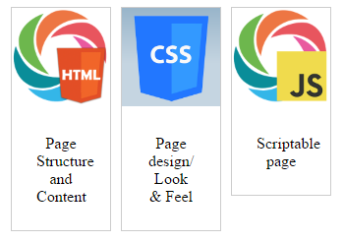

While clicking on each image, show large size image

**Image.html-30 Minutes**

<!DOCTYPE html>

<html>

<head>

<style>

div.gallery {

margin: 5px;

border: 1px solid #ccc;

float: left;

width: 180px;

}

div.gallery:hover {

border: 1px solid #777;

}

div.gallery img {

width: 100%;

height: auto;

}

div.desc {

padding: 15px;

text-align: center;

}

</style>

</head>

<body>

<div class="gallery">

<a href="ImageGallery.html">

<img src="ComputingKids.png" alt="ComputingKids" width="300" height="200">

</a>

<div class="desc">Computing Kids is an educational enrichment program for children in grades K-8 in the Seattle and Eastside area.</div>

</div>

</body>

</html>

**ImageGallery.html**

<!DOCTYPE html>

<html>

<head>

<style>

div.gallery {

margin: 5px;

border: 1px solid #ccc;

float: left;

width: 100px;

}

div.gallery:hover {

border: 1px solid #777;

}

div.gallery img {

width: 100%;

height: auto;

}

div.desc {

padding: 25px;

text-align: center;

}

</style>

</head>

<body>

<div class="gallery">

<a href="html.png">

<img src="html.png" alt="HTML" width="200" height="400">

</a>

<div class="desc">Page Structure and Content</div>

</div>

<div class="gallery">

<a href="css.png">

<img src="css.png" alt="CSS" width="200" height="400">

</a>

<div class="desc">Page design/ Look & Feel</div>

</div>

<div class="gallery">

<a href="JS.png">

<img src="JS.png" alt="JavaScript" width="200" height="400">

</a>

<div class="desc">Scriptable page</div>

</div>

</body>

</html>

**Lecture on CSS Form-20 Minutes**

**Styling Input Fields**

Use the width property to determine the width of the input field:

input {  
    width: 100%;  
}

 If you only want to style a specific input type, you can use attribute selectors:

* input[type=text] - will only select text fields
* input[type=password] - will only select password fields
* input[type=number] - will only select number fields

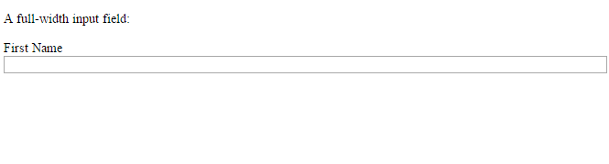

<!DOCTYPE html>

<html>

<head>

<style>

input {

width: 100%;

}

</style>

</head>

<body>

<p>A full-width input field:</p>

<form>

<label for="fname">First Name</label>

<input type="text" id="fname" name="fname">

</form>

</body>

</html>

## Padded Inputs

Use the padding property to add space inside the text field.

**Tip:** When you have many inputs after each other, you might also want to add some margin, to add more space outside of them:

input[type=text] {  
    width: 100%;  
    padding: 12px 20px;  
    margin: 8px 0;  
    box-sizing: border-box;  
}

Note that we have set the box-sizing property to border-box. This makes sure that the padding and eventually borders are included in the total width and height of the elements.

## Bordered Inputs

Use the border property to change the border size and color, and use the border-radius property to add rounded corners:

input[type=text] {  
    border: 2px solid red;  
    border-radius: 4px;  
}

## Colored Inputs

Use the background-color property to add a background color to the input, and the color property to change the text color:

input[type=text] {  
    background-color: #3CBC8D;  
    color: white;  
}

## Input with icon/image

If you want an icon inside the input, use the background-image property and position it with the background-position property. Also notice that we add a large left padding to reserve the space of the icon:

input[type=text] {  
    background-color: white;  
    background-image: url('search.jpg');  
    background-position: 10px 10px;   
    background-repeat: no-repeat;  
    padding-left: 40px;  
}

## Styling Select Menus

select {  
    width: 100%;  
    padding: 16px 20px;  
    border: none;  
    border-radius: 4px;  
    background-color: #f1f1f1;  
}

## Styling Input Buttons

## input[type=button], input[type=submit], input[type=reset] {     background-color: #4CAF50;     border: none;     color: white;     padding: 16px 32px;     text-decoration: none;     margin: 4px 2px;     cursor: pointer; } /* Tip: use **width: 100%** for full-width buttons */

**Activity-1 Hour**

## 

<!DOCTYPE html>

<html>

<head>

<style>

input[type=text] {

width: 100%;

padding: 12px 20px;

margin: 8px 0;

box-sizing: border-box;

border: 2px solid red;

border-radius: 4px;

background-color: #3CBC8D;

color: white;

}

#input1[type=text] {

width: 100%;

box-sizing: border-box;

border: 2px solid #ccc;

border-radius: 4px;

font-size: 18px;

color: black;

background-color: white;

background-image: url('search.jpg');

background-position: -20px -15px;

background-repeat: no-repeat;

padding: 15px 15px 15px 40px;

}

select {

width: 100%;

padding: 16px 20px;

border: none;

border-radius: 4px;

background-color: #f1f1f1;

}

input[type=button], input[type=submit], input[type=reset] {

background-color: #4CAF50;

border: none;

color: white;

padding: 16px 32px;

text-decoration: none;

margin: 4px 2px;

cursor: pointer;

}

</style>

</head>

<body>

<form>

<label for="fname">First Name</label>

<input type="text" id="fname" name="fname">

<input type="text" id="input1" name="search" placeholder="Search..">

<select id="country" name="country">

<option value="au">Australia</option>

<option value="ca">Canada</option>

<option value="usa">USA</option>

</select>

<p>Styled input buttons.</p>

<input type="button" value="Button">

<input type="reset" value="Reset">

<input type="submit" value="Submit">

</form>

</form>

</body>

</html>

**Also try this one:-**

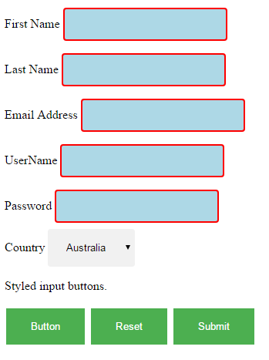

<!DOCTYPE html>

<html>

<head>

<style>

input[type=text] {

padding: 12px 20px;

margin: 8px 0;

box-sizing: border-box;

border: 2px solid red;

border-radius: 4px;

background-color: lightblue;

color: white;

}

input[type=email] {

padding: 12px 20px;

margin: 8px 0;

box-sizing: border-box;

border: 2px solid red;

border-radius: 4px;

background-color: lightblue;

color: white;

}

input[type=password] {

padding: 12px 20px;

margin: 8px 0;

box-sizing: border-box;

border: 2px solid red;

border-radius: 4px;

background-color: lightblue;

color: white;

}

select {

padding: 16px 20px;

border: none;

border-radius: 4px;

background-color: #f1f1f1;

}

input[type=button], input[type=submit], input[type=reset] {

background-color: #4CAF50;

border: none;

color: white;

padding: 16px 32px;

text-decoration: none;

margin: 4px 2px;

cursor: pointer;

}

</style>

</head>

<body>

<form>

<label for="fname">First Name</label>

<input type="text" id="fname" name="fname">

<br>

<label for="lname">Last Name</label>

<input type="text" id="lname" name="lname">

<br>

<label for="Email">Email Address</label>

<input type="email" id="Email" name="Email">

<br>

<label for="uname">UserName</label>

<input type="text" id="uname" name="uname">

<br>

<label for="pwd">Password</label>

<input type="password" id="pwd" name="pwd">

<br>

<label for="country">Country</label>

<select id="country" name="country">

<option value="au">Australia</option>

<option value="ca">Canada</option>

<option value="usa">USA</option>

</select>

<br>

<p>Styled input buttons.</p>

<input type="button" value="Button">

<input type="reset" value="Reset">

<input type="submit" value="Submit">

</form>

</form>

</body>

</html>